**CERTIFICATE** 

Maharashtra State Board Of Technical Education, Mumbai

(Collage name)

**Subject: Computer Graphics (22318)**

***Topic :- SHOOTING GAME***

**Guide: …….(teacher name)**

Submitted by:

|  |  |
| --- | --- |
| **Roll No.** | **Name** |
|  | (enter names of group members) |

Of second semester of diploma in Computer in Technology of institute (collage name) have completed the micro project work satisfactorily under the guidance of **(teacher name)** in the academic year 2019-2020 as prescribed in the I-Scheme curriculum

Project guide H.O.D Principal

 

**MAHARASHTRA STATE BOARD**

**OF TECHNICAL EDUCATION**

Certificate

This is to certify that **(name of student)** Of Third Semester of Dipoma in Computer Technology of Institute(Collage name) has completed the micro project work satisfactorily In subject  **Computer Graphics(22318)** for the academic year (your academic year) as prescribed in the I-Scheme curriculum.

**Place : (city) Enrollment no. :**

**Date: ………………. Exam seat no:……………….**

Project guide H.O.D Principal

**(teacher name)**

Acknowledgement

We wish to express our profound and sincere gratitude to our guide **(teacher name)**, who guided us in the structure of micro project as well as some main points in that micro project also they cleared our all doubts about micro project .We are Indebted to his constant encouragement, co-operation and help .It was his enthusiastic support that helped us in overcoming various obstacles in the project.

We would also like to express our thankfulness to our beloved Principal as well as HOD and other faculty members of our second year department for extending their support and motivation

Finally, we completed our micro project that regarding to our syllabus as well as department, once more thanks for all Group members, Respected **Principal, HOD** and other Faculty Members who helped us in the micro project completion.

Thanks!!

**PART A – Micro-Project Proposal**

**Title of Micro-Project**

**1.0 Brief Introduction**

The micro-project includes the Shooting game. It is the simple

Fun shooting game.

**2.0 Aim of the Micro-Project** (in about 1 to 2 Sentences)

This Micro-Project aims at:

The aim e is to develop the skill of creating or developing Mini Project using computer graphics. The aim of this Micro Project is to have fun with develop games that can be developed through computer graphics & animation.

1. **Intended Course Outcomes**
2. Manipulate visual and geometric information of images.
3. Implement standard algorithms to draw various graphics object using C programing.

**4.0 Literature Review**

We searched information for the suggest topic. Collected the data required for the micro -project.

**5.0 Proposed Methodology**

1. First searched for the suggested micro-project.
2. Collected information for the suggested topic.
3. Started for the micro-project.
4. Completed micro-project.
5. Showed to respected teacher.
6. Teacher regarded of some changes.
7. Done the changes into the project as told by teacher.

**6.0 Resources Required.**

|  |  |  |  |  |
| --- | --- | --- | --- | --- |
| **S. No.** | **Name of Resource/material** | **Specifications** | **Qty** | **Remarks** |
|  | Laptop / PC | Windows 7 ultimate / Windows 10 | 1 | - |
|  | W3schools | Website | 1 | - |

**7.0 Action Plan** (Sequence and time required for major activities for 8 Weeks)

|  |  |  |  |  |
| --- | --- | --- | --- | --- |
| **S. No.** | **Details of activity** | **Planned Start date** | **Planned Finish date** | **Name of Responsible Team Members** |
|  | Searched for topic of micro-project |  |  |  |
|  | Topic searched: -   1. Shooting game 2. Hotel Management 3. GUI based Simple Movie Ticket Booking System |  |  |  |
|  | Discussed with teacher about the topic |  |  |  |
|  | Teacher approved for Shooting game |  |  |  |
|  | Created prototype of our project |  |  |  |
|  | Started for developing the |  |  |  |
|  | Gathered information |  |  |  |
|  | Fixed errors and bugs |  |  |  |
|  | Completed the total project |  |  |  |
|  | Showed program to teacher and she suggested some corrections |  |  |  |
|  | We made the suggested correction |  |  |  |
|  | Teacher approved the project |  |  |  |

|  |  |  |
| --- | --- | --- |
| Sr. No. | Title | Page no. |
| 1 | Introduction |  |
| 2 | Aim |  |
| 3 | Advantages |  |
| 4 | Course Outcome |  |
| 5 | Literature Review |  |
| 6 | Actual Methodology |  |
| 7 | Resource |  |
| 8 | Source Code |  |
| 9 | Output |  |
| 10 | Skill Developed |  |
| 11 | Application |  |
| 12 | Area of Future |  |
| 13 | Reference |  |
| 14 | Conclusion |  |

INDEX

INTRODUCTION

In This Micro-Project we made / developed a simple shooting game using Computer graphics of C language. The game is developed using different graphics functions

The main header file is ‘graphics’’ which includes its function to set the color, background color, etc.

Shouting Game

The game is works on user input. The input is taken through the keyboard. The game is made only for the fun. It also can be learned we can develop the game through the C language also. It is a single level game which has the two target on two towers.

It is somewhat different from all the other game. It specifies the direction of wind flowing and the distance of the target from us(scope).

To aim the perfect shoot, you have to aim such that the line on the downside of scope specifies the distance and the line on horizontal line specifies the flow of wind.

It also includes different scene which include main menu, loading screen, end screen. It also displays your score, bullets left in the magazine, reload.

AIM

The aim is to develop the skill of creating or developing Mini Project. The aim of this Micro Project is to have fun with the games that can be developed through it.

Also, to develop more game like this. And to get learn more concept related to computer graphics & animation.

ADVANTAGES

* It is very simple fun game.
* Get to learn newer concept.
* Used graphics functions
* Implemented real life physics.

Course Outcomes

* Manipulate visual and geometric information of images.
* Implement standard algorithms to draw various graphics object using C programing

Literature Review

In This Micro-Project we created a Simple Shooting game using Computer graphics. We made this Micro-Project Using C Language. This Micro Project contains limited features but the essential one. The User can move his aim and shoot the targets. I also Implemented law of bullet drag, reload.

Actual Methodology

* First searched for the suggested Micro-project.
* Collected information for the suggested topic.
* Started the Micro-project.
* Completed Micro-project.
* Showed to respected teacher.
* Submitted the Micro-project.

RESOURCE

1. Software-Turbo C++
2. Software-Codebooks And Dave C++
3. Windows 10 Home.
4. W3schools.com (To learn Some File Handling Concepts).
5. YouTube: Some programming/File Handling Tutorials.

#include<stdio.h>

#include<graphics.h>

#include<conio.h>

#include<stdlib.h>

#include<math.h>

#include<string.h>

int x=300,y=150;

int down[7];

int right[7];

int left[7];

int flag=0;

int flag_target[10]={0,0,0,0,0,0,0,0,0,0};

void aim(int a,int b)

{

left[0]=a-20;

left[1]=a-40;

left[2]=a-60;

left[3]=a-80;

left[4]=a-100;

left[5]=a-120;

left[6]=a-140;

right[0]=a+20;

right[1]=a+40;

right[2]=a+60;

right[3]=a+80;

right[4]=a+100;

right[5]=a+120;

right[6]=a+140;

down[0]=b+20;

down[1]=b+40;

down[2]=b+60;

down[3]=b+80;

down[4]=b+100;

down[5]=b+120;

down[6]=b+140;

line(left[0],b+3,left[0],b-3);

line(left[1],b+5,left[1],b-5);

line(left[2],b+5,left[2],b-3);

line(left[3],b+5,left[3],b-5);

line(left[4],b+5,left[4],b-3);

line(left[5],b+5,left[5],b-5);

line(left[6],b+5,left[6],b-3);

line(right[0],b+3,right[0],b-3);

line(right[1],b+3,right[1],b-5);

line(right[2],b+3,right[2],b-3);

line(right[3],b+3,right[3],b-5);

line(right[4],b+3,right[4],b-3);

line(right[5],b+3,right[5],b-5);

line(right[6],b+3,right[6],b-3);

line(a+3,down[0],a-3,down[0]);

line(a+5,down[1],a-5,down[1]);

line(a+3,down[2],a-3,down[2]);

line(a+5,down[3],a-5,down[3]);

line(a+3,down[4],a-3,down[4]);

line(a+5,down[5],a-5,down[5]);

line(a+3,down[6],a-3,down[6]);

}

void about()

{

cleardevice();

outtextxy(250,50,"HOW TO PLAY ?");

outtextxy(10,150,"-to move your scope to right press 'd'");

outtextxy(10,170,"-to move your scope to left press 'a'");

outtextxy(10,200,"-to move your scope to up press 'w'");

outtextxy(10,230,"-to move your scope to down press 's'");

outtextxy(10,260,"-to shooot bullet press 'space'");

outtextxy(10,290,"-if your bullet hits your score will increase ");

outtextxy(10,320," -you are not a terminator!!! you have limited bullets ");

outtextxy(250,350," press any key to countinue ");

getch();

}

void loading()

{

int i;

outtextxy(200,200,"LOADING.....");

rectangle(200,240,450,280);

for(i=1;i<=250;i++)

{

delay(10);

line(200+i,240,200+i,280);

}

about();

cleardevice();

}

void level1()

{

setbkcolor(CYAN);

{

int top=20;

if(flag==1)

{

top=sqrt(((right[3]-115)*(right[3]-115))+((down[3]-275)*(down[3]-275)));

}

if(top>15 && flag_target[0]==0)

{line(100,350,115,310);

line(130,350,115,310);

line(115,310,115,290);

line(115,290,100,310);

line(115,290,130,310);

circle(115,275,15);

} else{flag_target[0]=1;}

rectangle(80,250,150,350);

line(80,315,150,315);

line(80,350,80,getmaxy());

line(85,350,85,getmaxy());

line(150,350,150,getmaxy());

line(145,350,145,getmaxy());

line(90,350,90,315);

line(110,350,110,315);

line(130,350,130,315);

line(145,350,145,315);

}

//tower2

{

int top=20;

if(flag==1)

{

top=sqrt(((right[3]-415)*(right[3]-415))+((down[3]-275)*(down[3]-275)));

}

if(top>15 && flag_target[1]==0)

{line(400,350,415,310);

line(430,350,415,310);

line(415,310,415,290);

line(415,290,400,310);

line(415,290,430,310);

circle(415,275,15);

}else{flag_target[1]=1;}

rectangle(380,250,450,350);

line(380,315,450,315);

line(380,350,380,getmaxy());

line(385,350,385,getmaxy());

line(450,350,450,getmaxy());

line(445,350,445,getmaxy());

line(390,350,390,315);

line(410,350,410,315);

line(430,350,430,315);

line(445,350,445,315);

}

flag=0;

}

int menu()

{

char choice;

int X,Y,rec[4],i;

X=(getmaxx()/2)-150;

Y=getmaxy();

rec[0]=X+40;

rec[2]=rec[0]+200;

rec[1]=Y+30;

rec[3]=Y+200;

settextstyle(1,0,2);

setbkcolor(BLACK);

setcolor(WHITE);

for(i=0;i<=400;i+=5)

{

delay(50);

cleardevice();

outtextxy(X+50,Y-i,"LONEWOLF");

rectangle(rec[0],rec[1]-i,rec[2],rec[3]-i);

outtextxy(rec[0]+50,(rec[1]+20)-i,"PLAY");

line(rec[0],(rec[1]+56)-i,rec[0]+200,(rec[1]+56)-i);

outtextxy(rec[0]+40,(rec[1]+76)-i,"ABOUT");

line(rec[0],(rec[1]+112)-i,rec[0]+200,(rec[1]+112)-i);

outtextxy(rec[0]+50,(rec[1]+136)-i,"QUIT");

}

choice=getch();

switch(choice)

{

case 'p':

cleardevice();

loading();

break;

case 'q':

exit(1);

break;

case 'a':

about();

break;

}

cleardevice();

return 0;

}

int main()

{ int score=0;

int gd=DETECT,gm;

//scope

int dist=100,ammo; //target

char c,AMMO[3];

initgraph(&gd,&gm," ");

menu();

ammo=5;

while(1)

{

char wind[10],dist[10];

outtextxy(getmaxx()-240,20,"wind:40");

outtextxy(getmaxx()-260,40,"distance:400");

outtextxy(10,30,"Ammo:");

sprintf(AMMO,"%d",ammo);

outtextxy(100,30,AMMO);

setfillstyle(0,BLACK);

level1();

circle(x,y,160);

line(x-160,y,x+160,y);

line(x,y-160,x,y+160);

aim(x,y);

c=getch();

switch(c)

{

case 'a':

x-=10;

break;

case 'd':

x+=10;

break;

case 's':

y+=10;

break;

case 'w':

y-=10;

break;

case 'q':

menu();

break;

case ' ':

y-=20;

ammo--;

flag=1;

}

if(ammo==0)

{ settextstyle(0,0,3);

outtextxy(200,200,"GAME OVER!!");

getch();

menu();

setbkcolor(WHITE);

}

if(flag_target[0]==1 && flag_target[1]==1)

{

outtextxy(200,200,"MISSION PASS");

outtextxy(200,220,"RESPECT+");

getch();

menu();

}

cleardevice();

}

closegraph();

return 0;

}

OUTPUT

Main Menu

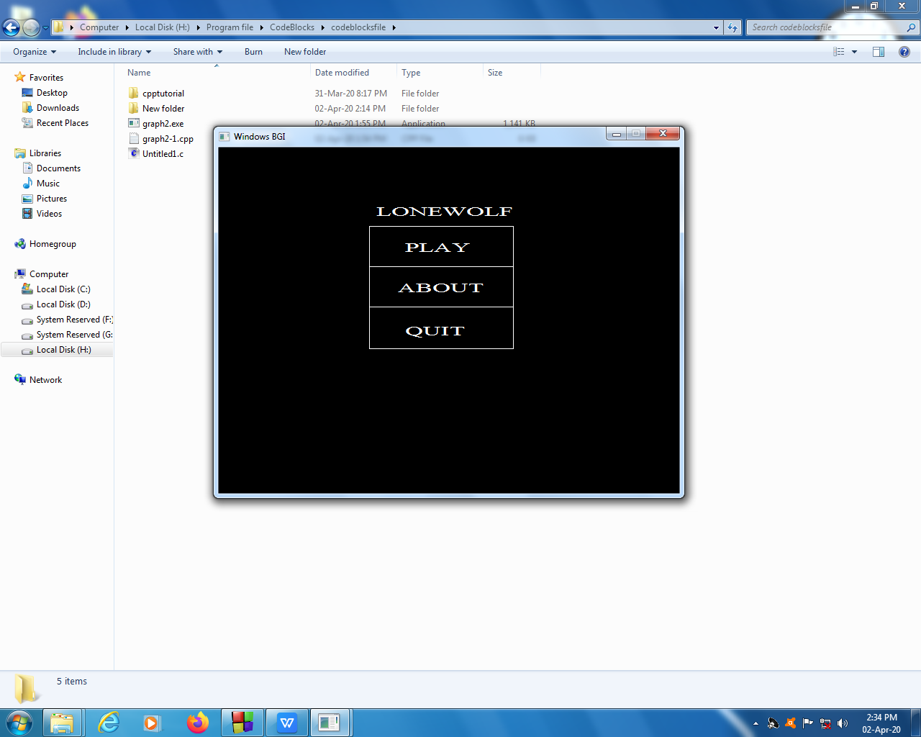

Loading

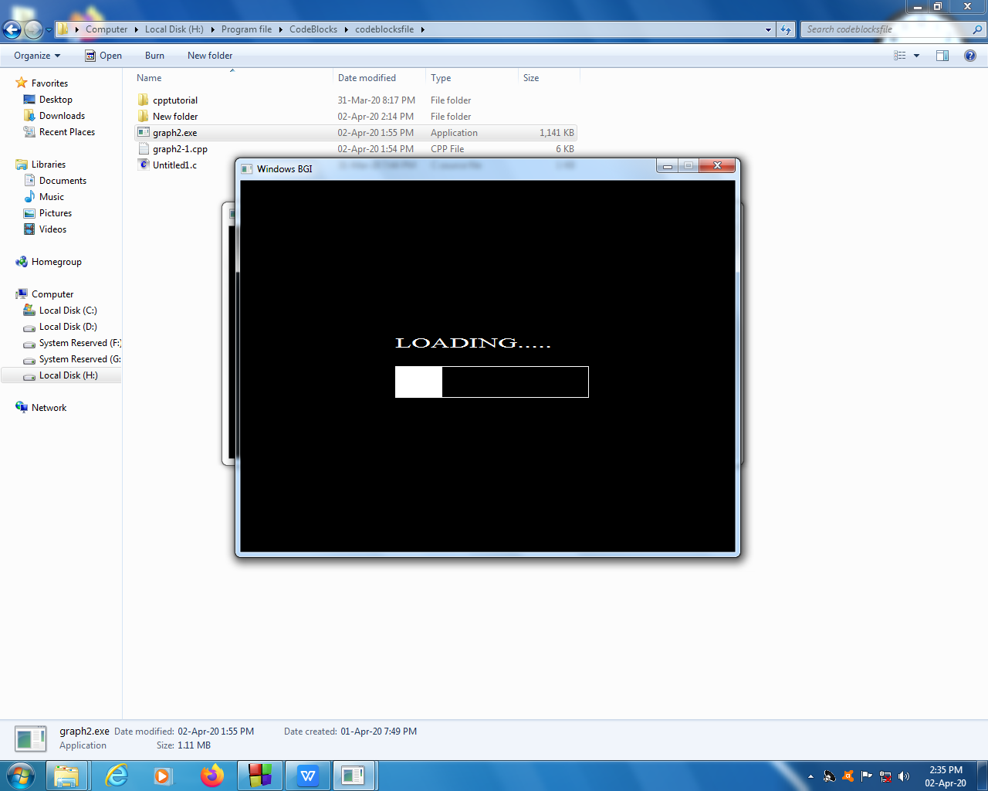

Instruction

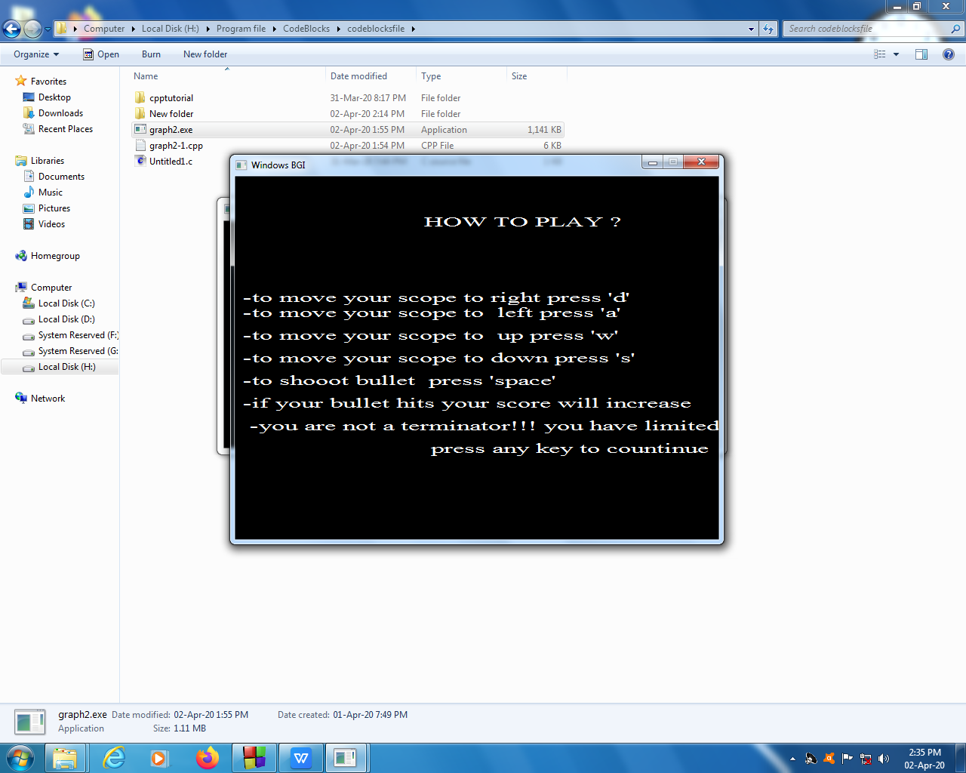

Before hitting

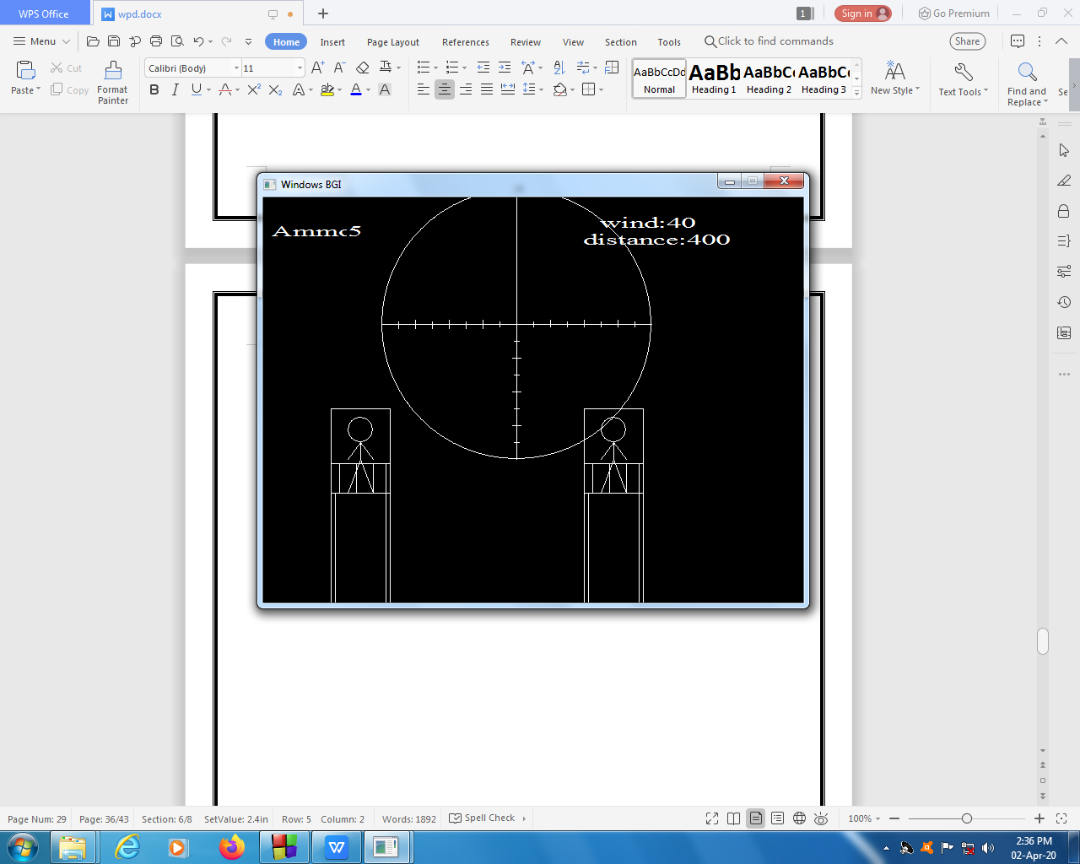

After hitting

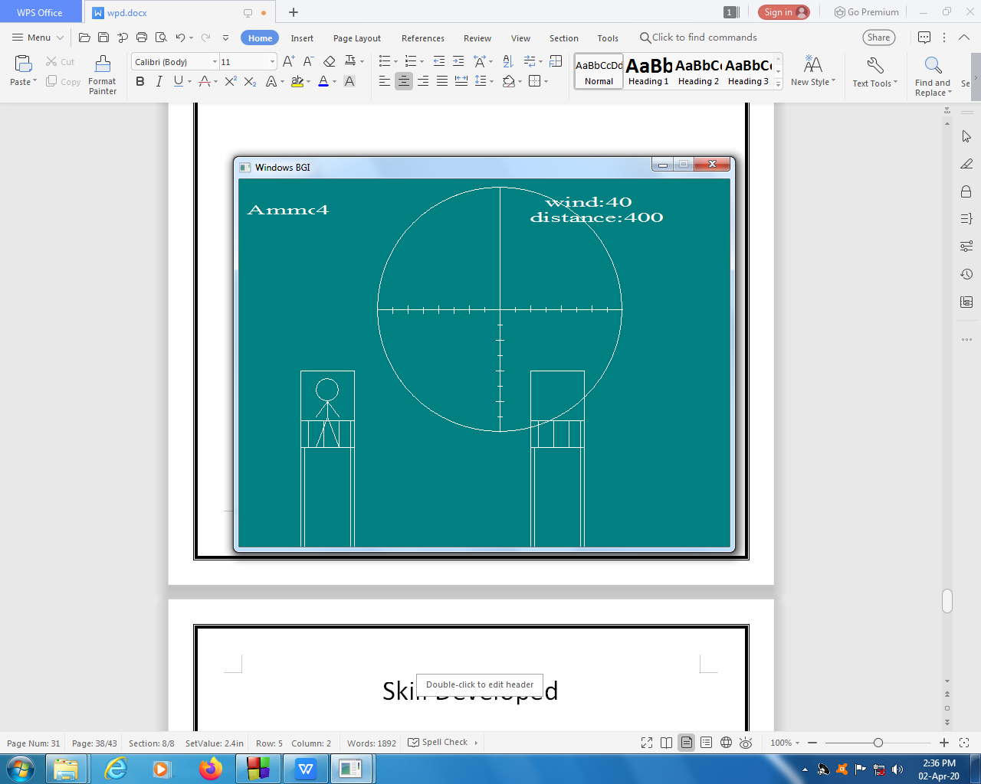

Skill Developed

* We learnt how to make a Simple Project using C language.
* We learnt how to use Compiler i.e.Turbo c++ and Dave c++.
* We got to know different types of function in ‘c’
* From this project we got know that how to create file format in ‘c’ and store information in that.

Application

The application of the micro-project is creating fun games using Graphics libraries in C. make use of different shapes of graphics to make different components of game (You can add more )

Area of future

We want to improve us by adding more levels, better graphic, Items.

REFERENCE

This Micro-project was completed under the guidance of our respected subject madam (teacher name).

The information of C language was also given by the mam and the rest information or Sum video tutorials related to c programmed was collected through w3schools.com website.

Websites: - <https://www.w3schools.com>

You Tube {Some File Handeling Tutorials}

Google {Information about different function in “C”etc.}

|  |  |
| --- | --- |
| Website | <https://www.w3schools.com/html/> |
| Youtube | <https://www.youtube.com/watch?v=wHFflWvii3M><https://www.youtube.com/watch?v=-G7bJVAIiEI> |

Conclusion

Hence from this Microproject we Learnt about how to write and compile programme in turbo.And from this project we learnt different types of function and their use in “C”.